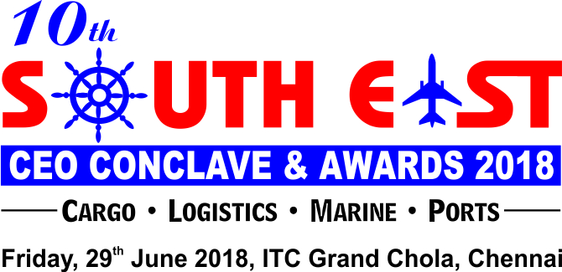

ENTRY FORM FOR NOMINATIONS**
We are inviting companies to submit entries describing how they have demonstrated innovations and excellence or improved their services
or product offering within the regions.
Entries will be evaluated against the set of criteria by panels of judges who will select and shortlist the winner for each category.
Qualifying Period : April 2017 to March 2018

Region
: South East India (New Mangalore to South of Andhra Pradesh)
**Categories (Please tick your nominated category):
P Use this symbol for selection of categories * Self Nomination & Suggestions/Recommendations are must
NOMINEE :
Name of the Person:
Name of the Company: Address: Telephone Number: E-mail Address:
NOMINATED BY:
Name of the Person:
Name of the Company: Address: Telephone Number: E-mail Address: Describe the achievements in not more than 500 words:
•
Supporting Documents: Only a limited amount of supporting documents may be submitted. (Eg. Relevant Certificates and Documents
pertaining to specified criteria norms only.)
Electronically completed entry should be mailed to nominations@exim-india.com
Note: No entries will be accepted in hard copy.

**The Jury/ Organisers reserve the right to make changes to the list of categories if required; due to lack of sufficient nominations/dearth of information, etc. The decision of the Jury / Organisers will be final & binding.
•
•

NOMINATION DEADLINE: WEDNESDAY, APRIL 25, 2018

To submit nominations in more than one categor y, use separate forms
Container Handling Port / Terminal of the Year
Container Shipping Line of the Year - Europe Trade Lane
Container Shipping Line of the Year - Far East Trade Lane

Container Shipping Line of the Year - America Trade Lane
Container Feeder Operator of the Year

Steamer Agent / Line of the Year - Dry Bulk Operator
Steamer Agent / Line of the Year - Break Bulk Operator
TUTICORIN REGION
NVOCC of the Year – GP / Special Equipment
LCL Consolidator of the Year (Export / Import)
Customs Broker of the Year (Export / Import)
STANDALONE CATEGORY
Container Freight Station of the Year (Public / Private)
Young Logistics Professional of the Year*
Inland Container Depot of the Year
Logistics Company of the Year*
Lifetime Achievement Award*

Freight Forwarder of the Year (Export / Import)
Container Freight Station of the Year - Multicargo
Woman Professional of the Year *
Stevedore of the Year

Fastest Growing Logistics Company of the Year*
Customs Broker of the Year (Sea & Air)
Car / Automobile Port of the Year
NVOCC of the Year (GP)
NVOCC of The Year – Middle East Trade Lane
Container Maintenance & Repairer of the Year

Dynamic Shipping & Logistics Professional of the Year*

