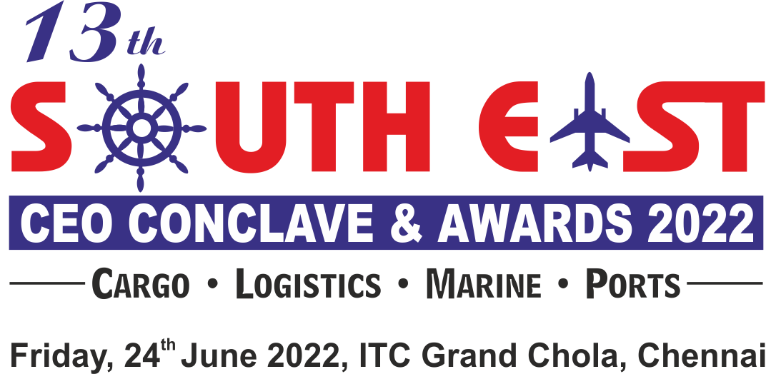

ENTRY FORM FOR NOMINATIONS**
We are inviting companies to submit entries describing how they have demonstrated innovations and excellence or improved their services Or product offering within the regions.
Entries will be evaluated against the set of criteria by panels of judges who will select and shortlist the winner for each category.
Qualifying Period : April 2020 to March 2021 & April 2021 to March 2022
Region : South East India (New Mangalore to South of Andhra Pradesh)
Categories (Please tick your nominated category):
☐ CONTAINER HANDLING PORT OF THE YEAR | ☐ CONTAINER FREIGHT STATION OPERATOR OF THE  YEAR
☐ CONTAINER HANDLING TERMINAL OF THE YEAR | ☐ CONTAINER TRANSPORT OPERATOR OF THE YEAR
☐ CONTAINER SHIPPING LINE OF THE YEAR - EUROPE  TRADE LANE | ☐ PROJECT CARGO MOVER OF THE YEAR
☐ CONTAINER SHIPPING LINE OF THE YEAR - FAR EAST  TRADE LANE | ☐ IT & SOFTWARE COMPANY OF THE YEAR  (MARITIME & LOGISTICS INDUSTRY)
☐ CONTAINER SHIPPING LINE OF THE YEAR - AMERICA  TRADE LANE | TUTICORIN REGION
☐ NVOCC OF THE YEAR - MIDDLE EAST TRADE LANE | ☐ FREIGHT FORWARDER OF THE YEAR
☐ STEAMER AGENT OF THE YEAR - DRY BULK OPERATOR | ☐ CUSTOMS BROKER OF THE YEAR (SEA & AIR)
☐ SHIPPING AGENT OF THE YEAR | ☐ CONTAINER FREIGHT STATION OPERATOR OF THE  YEAR
☐ SHIPPING AGENT OF THE YEAR - RO-RO | STANDALONE CATEGORY
☐ NVOCC OF THE YEAR | ☐ YOUNG LOGISTICS PROFESSIONAL OF THE YEAR*
☐ FREIGHT FORWARDER OF THE YEAR | ☐ DYNAMIC LOGISTICS PROFESSIONAL OF THE YEAR*
☐ LCL CONSOLIDATOR OF THE YEAR (EXPORT / IMPORT) | ☐ LOGISTICS COMPANY OF THE YEAR*
☐ CUSTOMS BROKER OF THE YEAR | ☐ LIFETIME ACHIEVEMENT AWARD*
☐ CUSTOMS BROKER OF THE YEAR (SME)

**The Jury / Organisers reserve the right to make changes to the list of categories if required; due to lack of sufficient nominations / dearth of information, etc. The decision of the Jury / Organisers will be final & binding.
Kindly click on the box for selected categories * Self Nomination & Suggestions/Recommendations are must
To submit nominations in more than one category, use separate forms

forms

NOMINEE:
Name of the Person
Name of the Company:
Address:
Telephone Number:
E-mail Address:
NOMINATED BY:
Name of the Person:
Name of the Company:
Address:
Telephone Number:
E-mail Address:
Describe the achievements in not more than 500 words:

- Supporting Documents: Only a limited amount of supporting documents may be submitted. (Eg. Relevant Certificates and Documents pertaining to specified criteria norms only.)
- Electronically completed entry should be mailed to : eximnominations@exim-india.com
- Note: No entries will be accepted in hard copy.
NOMINATION DEADLINE: THURSDAY, 28th APRIL 2022

